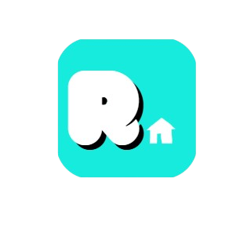

**RuralHub Mobile Application**

**User Manual**

**Table of Contents**

**1.** **Introduction** 3

**2.** **Installation, Registration and Login** 3

**3.** **Application Usage Overview** 6

**4.** **Profile** 7

7

**4.1** **Edit Personal Information** 7

**4.2** **View Account History** 8

**4.3** **Create and View and Edit Account Post** 9

**5.**  **Job Listing** 12

**5.1** **Search and Apply Job** 12

**6.**  **Job Application** 13

**7.**  **Offer Job** 14

**8.**  **Job in Progress** 15

**8.1** **Complete Job and Give Feedback** 15

**8.2** **Report Other Party** 16

**9.**  **Job Offered List** 17

**9.1** **Manage Job (Edit and Delete)** 17

**9.2** **Manage Applicants (View and Accept)** 18

**10.**  **Notification** 19

**11.**  **Chat** 20

**12.**  **Logout** 21

**13.**  **Questions about this Mobile App** 22

# **Introduction**

The RuralHub mobile app is designed to help bridge the employment gap in rural area. After installing the Mobile App, you will be able to:

* Search Jobs
* Apply Jobs
* Offer Jobs
* Manage Profile
* Manage Jobs
* Give and View Feedbacks

# **Installation, Registration and Login**

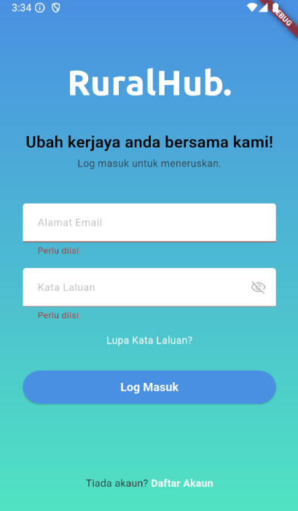To download the RuralHub Mobile App, install the apk [here](https://github.com/izzathakimi/henshin/releases). Make sure to select the latest version of RuralHub Mobile App apk.

Figure 2. 1 RuralHub Login

After the Mobile App has been installed and opened, the app will prompt you to enter the following information to login:

* **Email and Password**. Enter the email and password combination you use to during account registration.

After entering the information needed, click the “Log Masuk” button to gain access into RuralHub

However, if you do not have any account with RuralHub, click the “Daftar Akaun” text at the bottom of the login page, which will bring you to registration page.

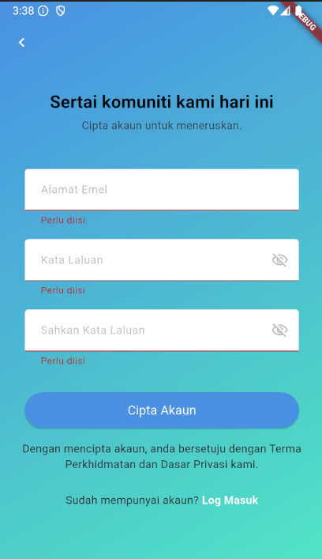After pressing the “Daftar Akaun” text, you will be brought to the Registration page, where you will be required to enter the following information to create an account:

Figure 2. 2 RuralHub Registration

* **Email and Password**. Enter the email and password combination you use to during account registration.
* **Password confirmation**. Enter the same password that you entered on the password form.

If you are not sure of the password entered, press the unhide button on the right side of the password form, and the password you entered will be shown.

After confirming all details are correct, click “Cipta Akaun” and you will be brought to the Personal Information page.

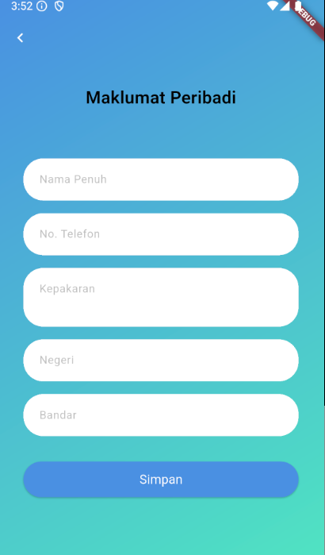After successfully creating an account, you will now be required to enter the following information as your personal information that will be displayed on your profile:

Figure 2. 3 Personal Information

* Full Name (Nama Penuh).   
   Enter your full name
  + - * Phone Number (No. Telefon). Enter your  
         phone number  
         Example: 01154108155
      * Specialty (Kepakaran). Enter your special  
         skills that may be used to attract hiring  
         personnel
      * State (Negeri). Enter the state that you are  
         living in now.
      * City (Bandar). Enter the city that you are  
         living in now.

After all forms all filled in, click “Simpan” and your information will be saved. You will be redirected to the Home Page after this step.

# **Application Usage Overview**

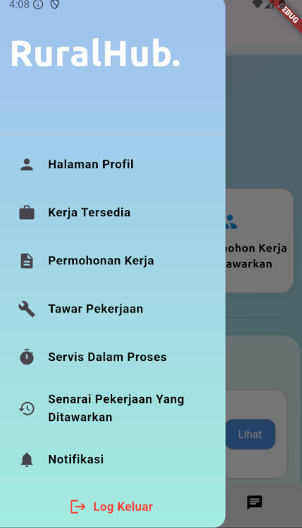You can access several RuralHub functions on the side and bottom navigation bar on any page of the Mobile App. Tap the side bar icon ≡ on the top left corner to view these options:

Figure 3. 1 Side Navigation Bar

* Profile (Halaman Profil)
* Job Listing (Kerja Tersedia)
* Job application (Permohonan Kerja)
* Off Job (Tawar Pekerjaan)
* Job in Progress (Servis dalam Proses)
* Job Offered List (Senarai Pekerjaan  
   Yang Ditawarkan)
* Notification (Notifikasi)
* Logout (Log Keluar). **Please note:**   
   Pressing this icon will log you out of the   
   Mobile App and you will have to re-login

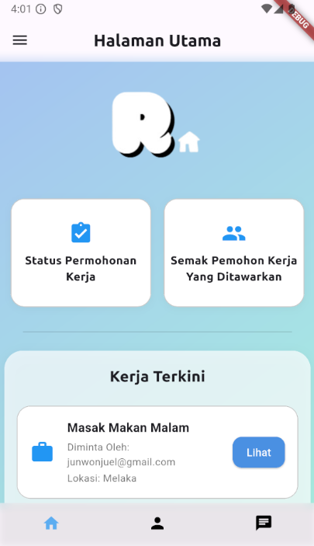

There are another three functions on the bottom navigation bar which are:

* Home
* Profile
* Chat

Figure 3.2 Bottom Navigation Bar

# **Profile**

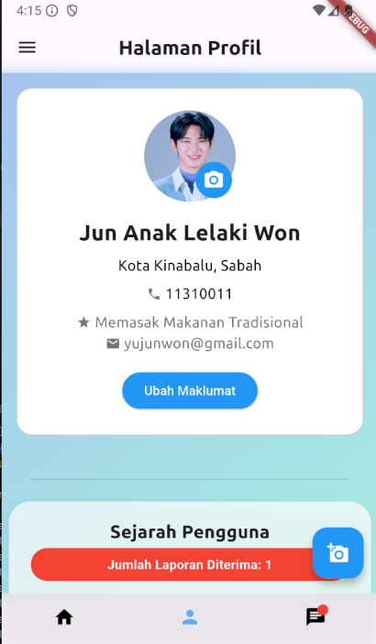You can view your own profile, where the informations you filled in after registration will show up, along with other functions such as:

* Edit Personal Information  
   (Ubah Maklumat)
* Account History   
   (Sejarah Pengguna)
* Post

When other user views your profile, they will not be able to use the Edit Personal Information and Post functions.

## 

Figure 4.1 Profile

## **4.1 Edit Personal Information**

To edit personal information, tap “Ubah Maklumat” button in blue, and a pop up will appear, and you may fill in any details that you wish to change:

Figure 4.2 Edit Personal Information

* Name (Nama). Enter your name
* Phone Number (Nombor Telefon).

Enter your phone number.

Example: 01154108155

* Specialty (Kepakaran). Enter your

Specialty.

* State (Negeri). Enter your current state
* City (Bandar). Enter your current city

## **4.2 View Account History**

To view the user account history, scroll down until you see the “Sejarah Pengguna” section. On this section, you will be able to see all jobs that the viewed user has done through RuralHub, and all jobs that the user have offered through RuralHub. To view more, tap the > button, and to go back to the job before, tap the < button.

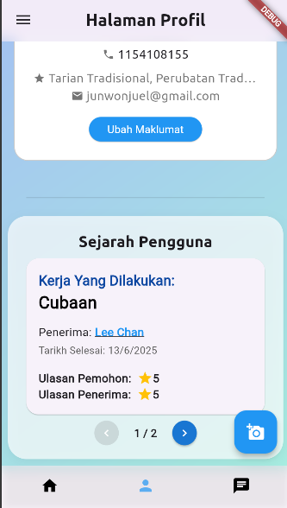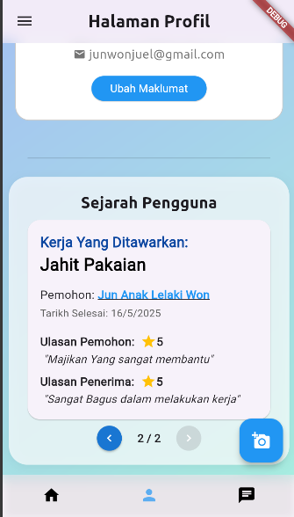

Figure 4. 4 View Account History Part 2

Figure 4. 3 View Account History Part 1

## **4.3 Create and View and Edit Account Post**

To create post to your profile, click the camera icon, located right on top of the bottom navigation bar, which is a blue button with a camera icon. You will then be navigated to the “Tambah Hantaran” page where you will be prompted to Choose a picture “Pilih Gambar” and add caption “Penerangan”. Only by submitting those two details will you be able to tap submit “Hantar” and create a post.

****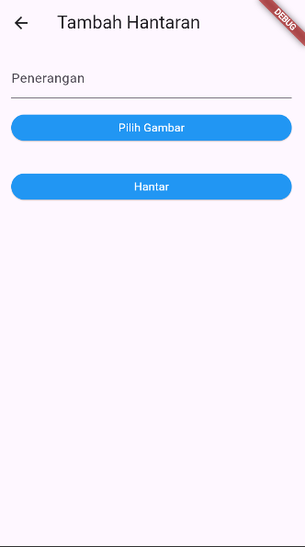

Figure 4. 5 Create Post Part 1

Figure 4. 6 Create Post Part 2

To view the post you have created, scroll down until you see the “Kandungan” Section. If you are the owner of the post, a post setting button ⋮, where it will show Edit “Sunting” or delete

“Padam” button.

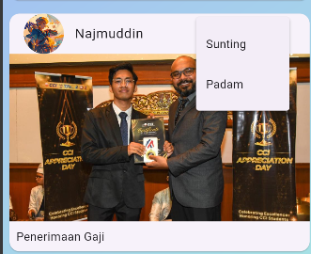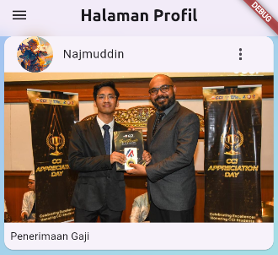

Figure 4. 8 View Post Part 2

Figure 4. 7 View Post Part 1

To edit the post, click the Edit “Sunting” option, and a popup will appear. It will then prompt you to enter new caption for the post, image edit is not included. If you do not wish to edit the caption, press cancel “Batal”, if you wish to edit, enter the new caption and press “Save”, which will update the post’s caption. If you wish to delete the post, you can either press delete “Sunting” in the edit section or after pressing the post setting button ⋮.

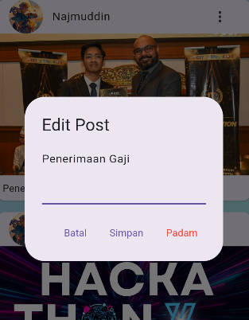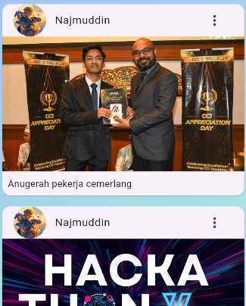

Figure 4. 9 Edit Post Part 1

Figure 4. 10 Edit Post Part 2

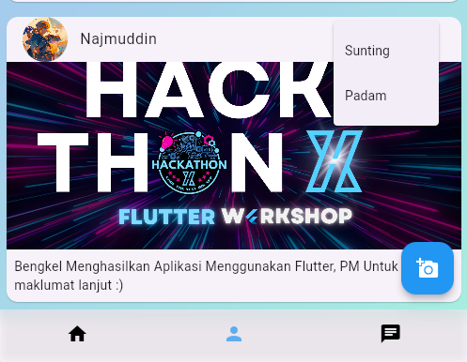

Figure 4. 11 Delete Post Part 1

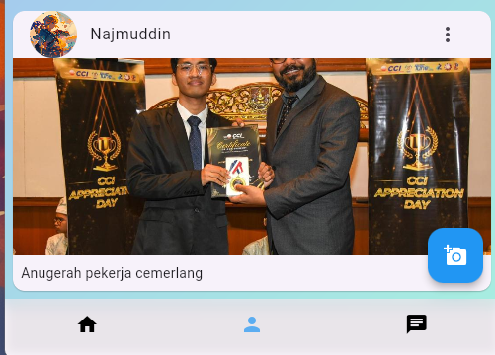

Figure 4. 12 Delete Post Part 2

# **5. Job Listing**

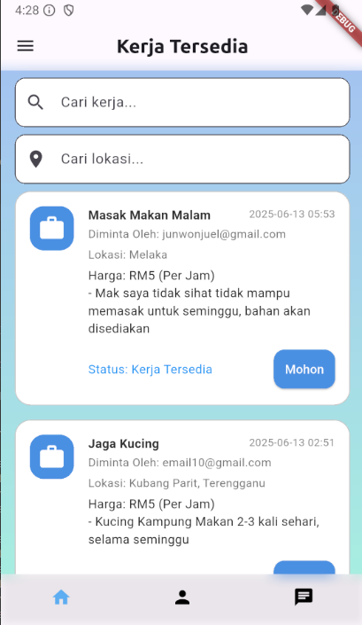On the job listing page, user can search for jobs using the search bar, and can apply for their desired jobs.

Figure 5. 1 Job Listing

## **5.1 Search and Apply Job**

Using the search bars on top of the job listing page, users can filter out jobs by:

* First search bar (Job Name Filter- Cari Kerja). Enter job name
* Second search bar (Location Filter- Cari Lokasi). Enter location name

The search bar is not mandatory; users are allowed to scroll to search for jobs if they prefer to. To apply for jobs, tap the apply “Mohon” button in blue, and the applied job will now be displayed at a different page: (Job Application).

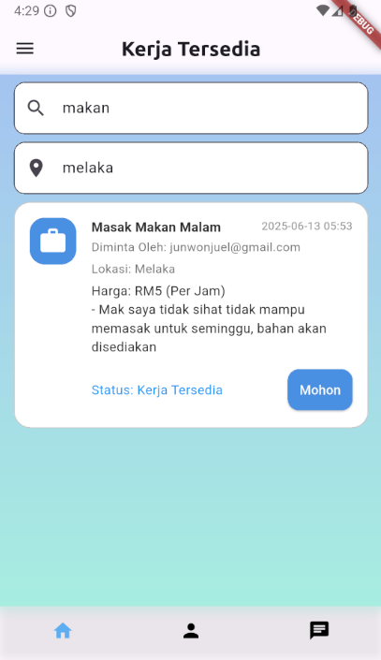

Figure 5. 3 Search Job Part 2

Figure 5. 2 Search Job Part 1

# **6. Job Application**

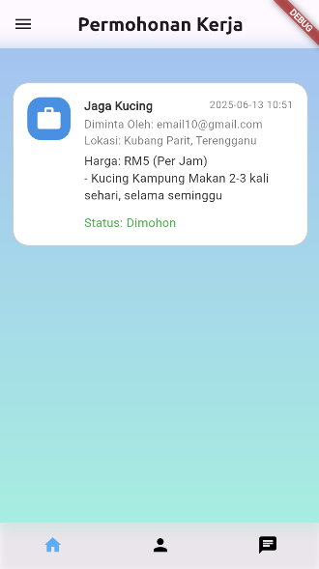The job application page is where the applied job appears, here user can see the status of their applied jobs. If the job is no longer available, it will no longer be shown on this page, and if the user is hired, it will then be displayed to: Job in Progress

Figure 6. 1 Job Application

# **7. Offer Job**

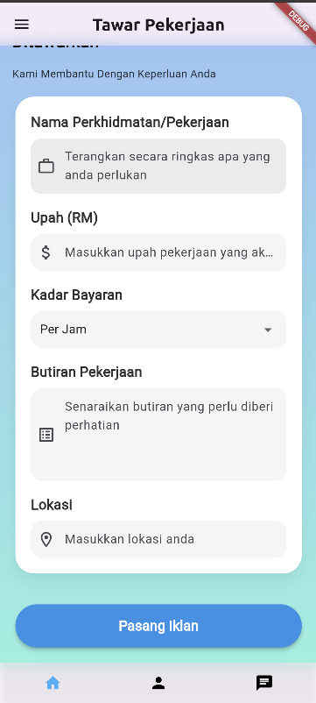

On this page, user can advertise job that are open for hiring. It will prompt you to fill in such details which are mandatory:

* Job Name   
   (Nama Perkhidmatan/Pekerjaan). Enter job title
* Fee (Upah (RM)). Enter job fee
* Payment Rate (Kadar Bayaran) A dropdown button will prompt you to choose between per Hour or per Day
* Job Description (Butiran Pekerjaan). Enter detailed information about the job
* Location (Lokasi). Enter job location

Only after filling in all details, will you be able to submit the form, by tapping the submit “Pasang Iklan” button.

Figure 7. 1 Offer Job

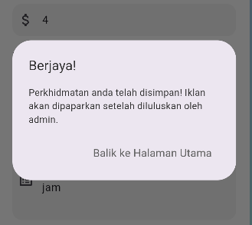

A popup notice will then appear and prompt user to return to home page while waiting for admin to approve their job offering.

Figure 7. 2 Job Offer Popup

# **8. Job in Progress**

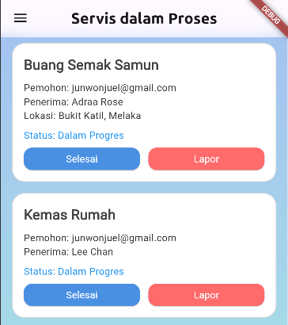

On this page, it will display all jobs that are ongoing for the user, whether it is them who is offering it, or it is them who is working in.

Figure 8. 1 Job in Progress

## **8.1 Complete Job and Give Feedback**

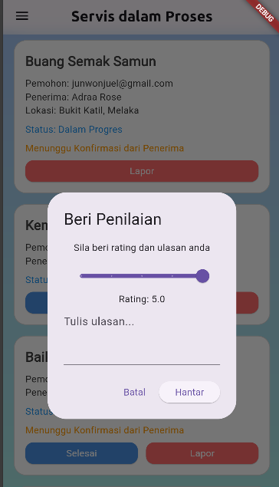If you have finished the job, or have confirmed that your worker has completed their job, you can press the complete “Selesai” button in blue, which will then display “Menunggu Konfirmasi dari Penerima/Pemohon” which means that the system is waiting for the other party to press the complete button before the job status changes to Finished “Selesai”. Once you tapped the complete button, it will prompt you to give feedback on the other party, rating is mandatory, but review “ulasan” can be left empty, or you can enter any comments you have on the other party and click submit “Hantar”. Completed job will be shown on View Account History

Figure 8. 3 Complete Job Part 2

Figure 8. 2 Complete Job Part 1

## **8.2 Report Other Party**

To report the other party if any inconvenience occurs, tap the report “Lapor” button in red, and it will prompt you to enter details of the report. Example: “Job description does not match real work”

And you can upload media as proof if available. Once all details are confirmed, press

the submit “Hantar Laporan” button in red. The report will be sent to admin, and will be waiting for admin verification before it is displayed at the reported user profile.

It will not display at the reported job “Laporan Telah Dibuat” which is report has been made.

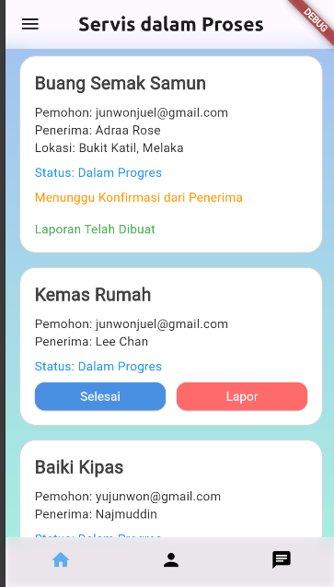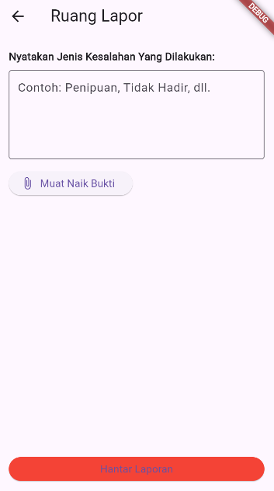

Figure 8. 5 Report Part 2

Figure 8. 4 Report Part 1

# **9. Job Offered List**

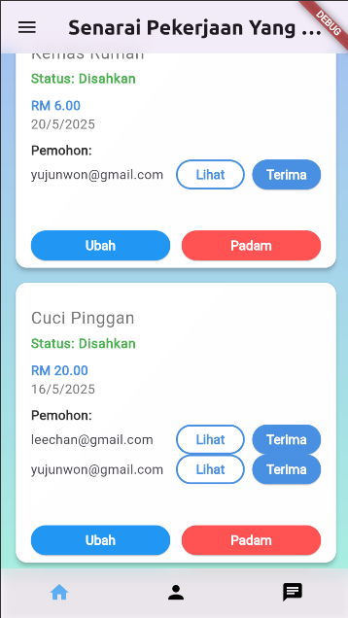On this page, you can view all jobs that you have offered, which you have not accept any applicants yet.

For each jobs offered, you can see their details, applicants, and manage them as necessary.

Jobs that have workers or have been completed will not be shown on this page.

Figure 9. 1 Job Offered List

## **9.1 Manage Job (Edit and Delete)**

For editing, tap the edit “Ubah” button in blue, and a popup will prompt you to update any details as you wish. The changeable details are job description (deskripsi), fee (upah), and payment rate (kadar bayaran), once you have confirmed all details, tap the submit “simpan” button and the new details will now be displayed

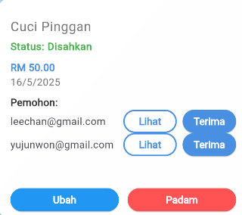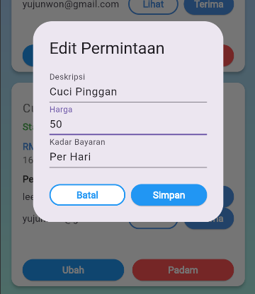

Figure 9. 2 Edit Job Part 2

Figure 9. 3 Edit Job part 1

To delete, press the delete “Padam” button in red, and a popup will ask for your confirmation to delete the job. If you change your mind, press cancel “Batal” or if you want to proceed, press delete “Padam.”

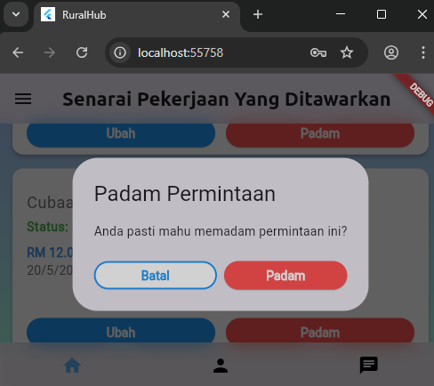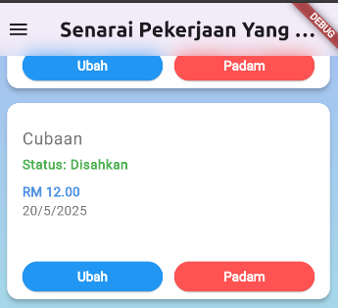

Figure 9. 5 Delete part 2

Figure 9. 4 Delete Part 1

## **9.2 Manage Applicants (View and Accept)**

Before accepting applicants, you can view their profile by tapping the view “Lihat” button beside the email of the selected applicant.

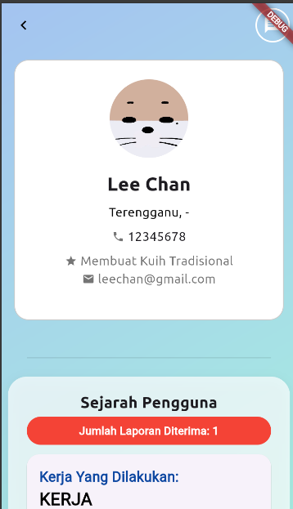

Figure 9. 6 View Part 1

Figure 9. 7 View Part 2

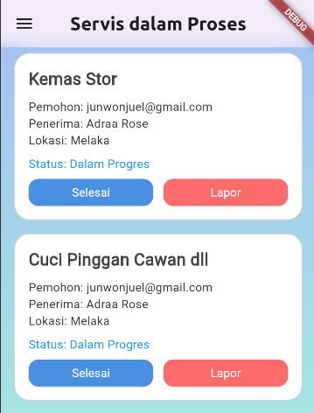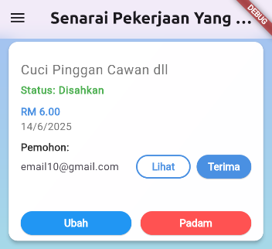If you think that the applicant is worthy, you can hire them by tapping the accept “Terima” button in blue beside the View “Lihat” button. Once accepted, the job will then be shown on the Job in Progress page.

Figure 9. 9 Accept Part 2

Figure 9. 8 Accept Part 1

# **10. Notification**

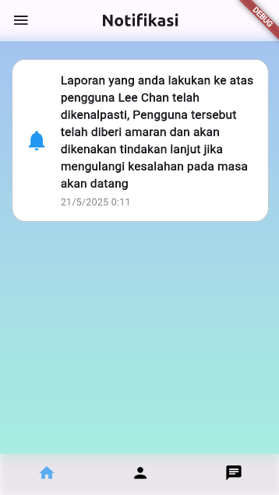

Figure 10. 1 Notification

For this page, if you receive any notifications, it will be shown here, if the Notification on the side navigation bar has a red icon, it means you have an unread notification.

# **11. Chat**

For chat, you can tap the chat button on the user you want to chat with, with the button located at the top right corner of the targeted user profile page.

Once you have tapped the button, you will be brought to the chat page, and you may enter any message and press the enter button beside the chat box. Your message will be sent to the targeted user, and they can view your message through the chat function on the rightmost section of the bottom navigation bar.

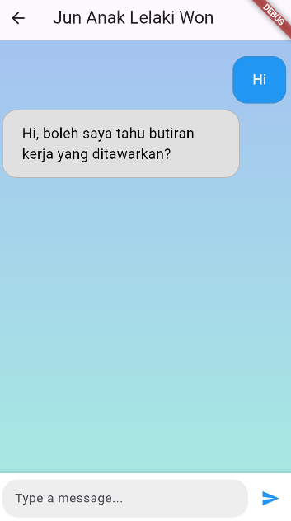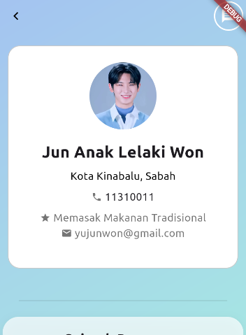

Figure 11. 2 Chat Part 2

Figure 11. 1 Chat Part 1

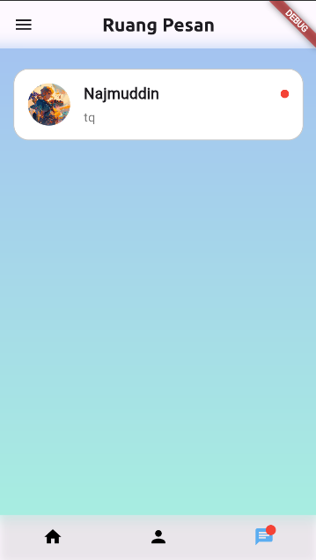Whenever you receive a new message from other user, a red circular icon will appear on the chat button and on the chat box of the sender

Figure 11. 3 Chat Part 3

# **12. Logout**

To logout, simply tap the log out “Log Keluar” button on the side navigation bar.

Figure 12. 2Logout Part 2

Figure 12. 1 Logout Part 1

# **13. Questions about this Mobile App**

For any questions about RuralHub Mobile App, please contact our customer care:  
 [izzathakimi@gmail.com](mailto:izzathakimi@gmail.com)